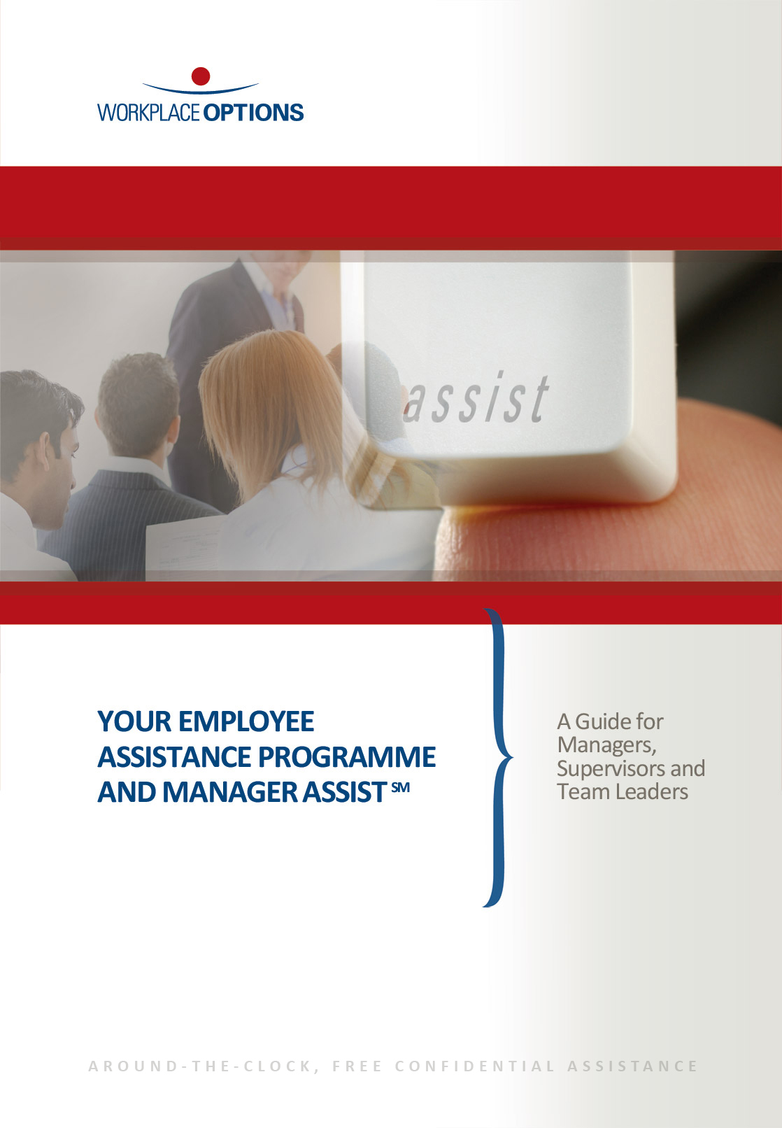

**Your Employee Assistance Programme and ManagerAssistSM**

*A Guide for Managers, Supervisors and Team Leaders*

**Your Employee Assistance Programme**

With ever increasing pressures at work and at home, there are times when we all need some extra support or practical information to balance the demands of every day life. That’s why your organisation has an Employee Assistance Programme (EAP) in place.

**Benefits to your organisation**

Having an EAP is a clear demonstration of a commitment to employee well-being. Happier employees with healthier attitudes and better well-being are able to focus more effectively at work, have higher morale and are more engaged. It also supports you as a manager, team leader or supervisor as more demands are placed upon you, and improves the management of absenteeism by addressing individuals’ concerns or problems early.

**Staffed by professionals**

Your EAP is provided by Workplace Options, an expert provider of employee support services. Our staff comprise a team of highly trained and qualified professionals who are experts in fields such as well-being, family matters, relationships, debt management, employment issues, consumer rights, counselling, and much more.

**Benefits of the EAP**

* **Free of charge.** The service is paid for by your employer.
* **Available 24 hours a day, 7 days a week, 365 days a year.**
* **Confidential**. Although your employer receives utilisation statistics on the number of people using the EAP and the issues raised, no personal, identifying information is disclosed. No-one at work will know that an individual has contacted us unless they choose to disclose this. The only information they have to provide is your employer’s name.
* **Accessible by a variety of methods**, including phone, email, our website and via instant messaging.
* **Information and resources on a whole range of work, family and personal issues.**
* **No limit** to the number of issues you can gain support on.
* **Independent** from your employer and completely impartial.

**Practical information**

Many of the issues that individuals face are of a practical, everyday nature. Giving the right information at the right time can help problems to be ‘nipped in the bud’ as well as enable people to resolve situations themselves. For example, issues such as budgeting or redundancy can be the prelude to more serious situations such as gambling or marital breakdown. The EAP can provide practical information including telephone information, fact sheets and information packs. We can even save time and legwork by searching for services in an individual’s local area, such as childcare and elder care providers.

**Short-term counselling**

When an individual is worried, anxious or is facing a difficult time in their life, your EAP can provide practical short-term counselling to help them get back on track. Our skilled counsellors can listen to employees and help them use their existing resources to move towards a solution which can also help restore confidence when it is at its lowest ebb. Counselling starts with a telephone assessment, followed by telephone, or face-to-face counselling, if appropriate.

**Examples of the issues covered**

From work-life balance to childcare, relationships to workplace issues, health and well-being to debt, elder care   
to consumer rights, we can provide support on a wide range of work, family and personal issues.

Please also refer to the *‘Achieving balance through total well-being and support’* A5 brochure for more details on the EAP.

**Manager AssistSM**

Management positions can be rewarding but also very challenging. Regardless of your experience, supporting an individual, or a team, while focusing on business needs can often be difficult. In addition to the support provided to you as an employee through your EAP, we can offer you a wide range of assistance in your role as a manager, team leader or supervisor through the ManagerAssist service.

Your ManagerAssistservice provides information and support on any subject which is impacting on you, an individual or your team. As a result, our experts can help you reduce your workload and free you up from the pressure of having to act as an informal counsellor.

**Benefits to you**

* Acts as a sounding board for talking through concerns you have about an individual.
* Provides advice on people management issues, in conjunction with your HR department.
* Offers guidance in supporting employees on key issues such as stress or workplace bullying.
* Provides a resource to refer employees to – both informally and formally.
* Provides feedback (when agreed) on an individual’s progress/engagement in obtaining support.

**Examples of the issues covered**

***Health, Safety & Well-being***

Drugs and alcohol

Mental health

Health and safety

Occupational health

Well-being initiatives

Stress/Work-life balance

Rehabilitation and return to work

***Diversity & Equality***

Bullying and harassment

Dignity at work

Discrimination

Equality

Diversity

Disabilities and sickness

***Learning & Development***

Careers

Coaching and training

Management techniques

Listening skills

Leadership



***Organisational Issues***

Change management

Retention

Contingency planning

Flexible working

Relocation

Redundancy

***Performance Management***

Appraisals and supervision

Disciplinary hearings

Grievances

Absence and attendance

Conflict and mediation

Performance

***Trauma/Critical incidents***

Loss of a colleague

Workplace accidents

Assault/Violence

Security/Terrorist incidents

Transport accidents

Minimum **Average levels of pressure** Maximum

m

**Performance**

**m**

**Pressure**

**m**

Panic

m

Strain

m

Stretch

m

Comfort

m

Boredom

m

**Balancing pressure and performance**

In today’s non-stop world, pressure is inevitable. Pressure can stimulate us to achieve, grow and learn. However pressure can also lead to stress. The way in which people respond to pressure impacts on both their performance and well-being. It is important to manage pressure and as a manager, supervisor or team leader, it’s important to recognise and understand how pressure affects employees.

The pressure-performance diagram (below) is a useful way to illustrate the relationship between pressure and performance. The diagram can be used as a tool to help identify levels of pressure for individuals and for working teams, although it is important to note that this varies from person to person and across time.

**Positive pressure**

When there is very little pressure on us to carry out a task, there is little incentive for us to focus energy and attention on it. This can result in boredom or a focus on other, more urgent tasks. As pressure on us increases, we move into the ‘comfort’ zone and through into ‘stretch’, the state in which most people achieve optimum performance. Here we are able to concentrate on the task and perform well – there is enough pressure on us to focus our attention but not so much that it disrupts our performance.

**Unhealthy stress**

However, it can be relatively easy to move from ‘stretch’ to ‘strain’ – the state which people often associate with stress. As we become stressed, distractions, difficulties, anxieties and negative thinking begin to surface. These compete with our performance of the task and as a result our concentration suffers, and our focus narrows as our brain becomes overloaded. As shown in the diagram above this can be a slippery slope – the more our brain is overloaded, the more our performance can suffer. The more our performance suffers, the more new distractions, anxieties and negative thinking happens. ‘Panic’ is the state when an individual can no longer cope and no longer functions in any way which is healthy.

**Addressing stress within your workplace**

**HSE’s management standards for work-related stress**

The Health & Safety Executive has identified six management standards which define the key areas of work design that, if not properly managed, are associated with poor health and well-being, lower productivity and increased sickness absence. In other words, the primary sources of stress at work. These are:

* [**Demands**](http://www.hse.gov.uk/stress/standards/demands.htm)[1] – this includes issues such as workload, work patterns and the work environment.
* [**Control**](http://www.hse.gov.uk/stress/standards/control.htm)**[2]** – how much say the person has in the way they do their work.
* [**Support**](http://www.hse.gov.uk/stress/standards/support.htm)[3] – includes the encouragement, sponsorship and resources provided by the organisation, line management and colleagues.
* [**Relationships**](http://www.hse.gov.uk/stress/standards/relationships.htm)[4] – this includes promoting positive working to avoid conflict and dealing with unacceptable behaviour.
* [**Role**](http://www.hse.gov.uk/stress/standards/role.htm)**[5]** – whether people understand their role within the organisation and whether the organisation ensures that they do not have conflicting roles.
* [**Change**](http://www.hse.gov.uk/stress/standards/change.htm)**[6]** – how organisational change (large or small) is managed and communicated.

*Source: http://www.hse.gov.uk/stress/standards*

**Spotting the early warning signs of stress**

***Physiological***

Weight loss/gain

Frequent colds or flu

Skin irritations

Backaches/Headaches

Chest pains

Workplace accidents

***Mental***

Difficulty focusing/following instructions

Prone to errors

Forgetfulness

Decrease in alertness

Decrease in concentration

***Behavioural***

Excessive sick leave/Lateness

Disruptive behaviour/Withdrawal

Change in the quality/quantity of work

Missed appointments/deadlines

Increased speed of talking

Reliance on alcohol/drugs

Scruffy appearance/hygiene issues

***Emotional***

Mood swings

Apathy

Hostility

Tearfulness

Change in attitude to colleagues



**Referring an employee to the EAP**

**Self-referral**

This requires no involvement from you as a manager and is the most common way that employees access the EAP. They can simply call, email or go online to access resources and support from an expert.

**Informal management referral**

An individual may approach you in distress or with a concern, and you can encourage them to call the EAP. You can remind them of our service, the skills of those who provide it and its confidentiality and independence from your organisation. You might also wish to offer the employee some time and a quiet, private space from where they can contact Workplace Options.

**Formal management referral**

If you identify an employee who may benefit from EAP support, you can formally refer them to the service by completing a referral form. They do not have to take up the support offered but if they choose to, and with their written consent, Workplace Options can make contact with them to provide support. Alternatively, the employee can contact Workplace Options themself.

Varying levels of feedback can also be obtained from Workplace Options, again with the written consent of the employee. Any referral is undertaken with discretion – we will maintain confidentiality and identities will not be disclosed to any third party.

Examples of instances where the formal referral process can help include an employee displaying unusual behaviour (such as turning up late for work), or seeing a drop in workplace performance. You may also wish to provide assistance in helping an individual return to work after a long absence.

**Critical incidents and trauma support**

Workplace Options provides counselling support to employees and teams in the event of a critical incident, whether they are directly involved in the incident or not. We can mobilise a critical incident response team to provide a structured debriefing within 48-72 hours of an event. Critical incidents include such events as:

* A traumatic accident on site e.g. an explosion or fire
* The death of a colleague
* Transport accidents e.g. a car accident or rail crash
* A threatened, or real, assault or violence
* Security and terrorist threats/incidents, such as an armed robbery or bomb threat

To arrange critical incident support all you need to do is contact Workplace Options, state which organisation you are from and that you have a critical incident. You will then be put through to an expert who can help.

*Please note: the provision of on-site support may be at an additional cost. Please check with your HR Department or EAP Consultant for further details.*

**About Workplace Options**

Founded in the UK in 1981 as Employee Advisory Resource, we were the first to introduce the concept of Employee Assistance Programmes to the UK. At the same time, in the United States, Workplace Options began to provide work-life consulting and training to organisations and in 1997 began offering resource and referral solutions to EAP and third-party organisations. In 2006, Workplace Options acquired Employee Advisory Resource, which had by this time established itself as one of the leading providers of Employee Assistance Programmes and integrated work-life services, both in the UK and across the globe.

Drawing from an international network of accredited providers and professionals, Workplace Options is today the world’s largest integrated EAP and work-life services provider. Service centres in London, Dublin, Raleigh (US), Toronto and Singapore support more than 34 million employees in 26,000 organisations, across 170 countries. To learn more please visit www.workplaceoptions.com.

**Contacting us**

**EAP FREEPHONE:** 0800 243 458

**MANAGER ASSISTSM FREEPHONE:** 0800 298 2021

**E-MAIL:** assistance@workplaceoptions.com

**WEBSITE:** www.workplaceoptions.com

**OUTSIDE THE UK:** +44 (0)20 8987 6550

**SMS (FOR CALL BACK):** +44 (0)7909 341229

**MINICOM:** +44 (0)20 8987 6574

